1. Sarah bought a new car in 2001 for $24,000. The dollar value of her car changed each year as shown in
the table below.
Value of Sarah’s Car
Year Value
2001 $24,000
2002 $22,500
2003 $19,700
2004 $17,500
2005 $14,500
2006 $10,000
2007 $ 5,800
Represent the following information using a line graph with following style properties
- X- axis - Year
- Y –axis - Car Value
- title –Value Depreciation (left Aligned)
- Line Style dashdot and Line-color should be red
- point using * symbol with green color and size 20

CODE:
import matplotlib.pyplot as plt
import numpy as np

xaxis = np.array([2007, 2006, 2005, 2004, 2003, 2002, 2001])
yaxis = np.array([5800, 10000, 14500, 17500, 19700, 22500, 24000])

plt.plot(xaxis, yaxis, linestyle="dashdot", c='r', marker= '*', ms='20', mfc='green', mec='green')
plt.title("Value Depreciation", loc='left')
plt.xlabel("Year")
plt.ylabel("Car Value")
plt.show()

OUTPUT:
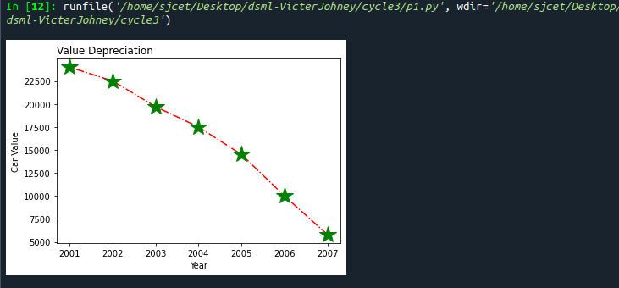
2. Following table gives the daily sales of the following items in a shop.
Subplot() provides multiple plots in one figure.
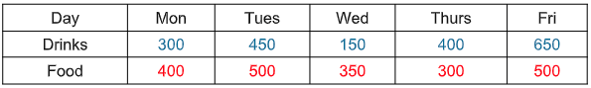
Use subplot function to draw the line graphs with grids(color as blue and line style dotted) for the
above information as 2 separate graphs in two rows
a) Properties for the Graph 1:

- X label- Days of week
- Y label-Sale of Drinks
- Title-Sales Data1 (right aligned)
- Line –dotted with cyan color
- Points- hexagon shape with color magenta and outline black
b) Properties for the Graph 2:
- X label- Days of Week
- Y label-Sale of Food
- Title-Sales Data2 ( center aligned)
- Line –dashed with yellow color
- Points- diamond shape with color green and outline red

CODE:
import matplotlib.pyplot as plt
import numpy as np

#xaxis = np.array([300, 450, 150, 400, 650])
#yaxis = np.array([400, 500, 350, 300, 500])

#plot1
xaxis = np.array(['Mon', 'Tues', 'Wed', 'Thurs', 'Fri'])
yaxis = np.array([300, 450, 150, 400, 650])
plt.subplot(1, 2, 1)
plt.plot(xaxis, yaxis, ':c', )
plt.plot(xaxis,yaxis,'Hm',mec='k')
plt.grid(color = 'blue', linestyle = 'dotted')
plt.title("Sales Data1", loc='right')
plt.xlabel("Days of Week")
plt.ylabel("Sale of Drinks")
plt.show()

#plot2
xaxis = np.array(['Mon', 'Tues', 'Wed', 'Thurs', 'Fri'])
yaxis = np.array([400, 500, 350, 300, 500])
plt.subplot(1, 2, 1)
plt.plot(xaxis, yaxis)
plt.plot(xaxis,yaxis,'--y')
plt.plot(xaxis,yaxis,'Dg',mec='r')
plt.grid(color = 'blue', linestyle = 'dotted')
plt.title("Sales Data2", loc='center')
plt.xlabel("Days of Week")
plt.ylabel("Sale of Food")
plt.show()

OUTPUT:
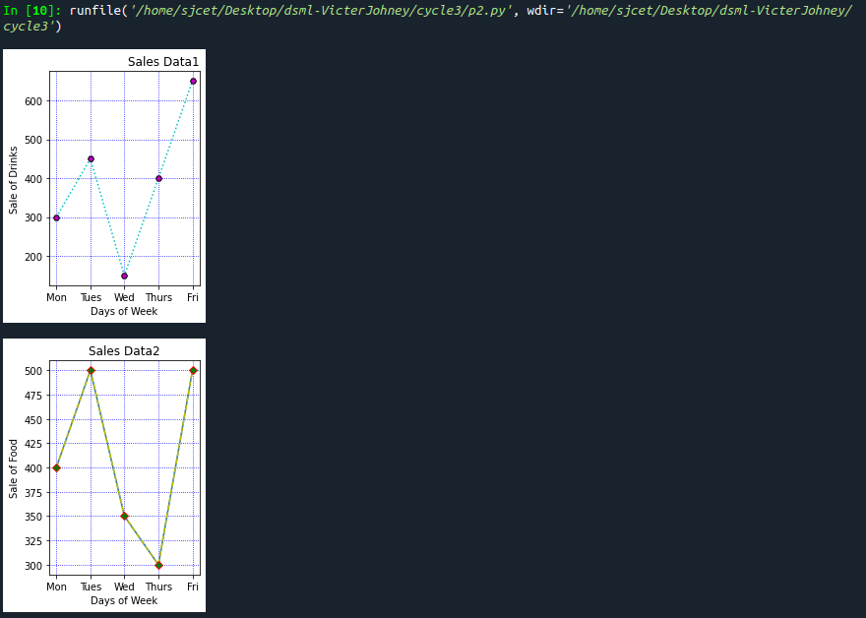
3. Create scatter plot for the below data:(use Scatter function)
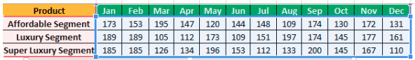
Create scatter plot for each Segment with following properties within one graph
- X Label- Months of Year with font size 18
- Y-Label- Sales of Segments
- Title –Sales Data
- Color for Affordable segment- pink
- Color for Luxury Segment- Yellow
- Color for Super luxury segment-blue

CODE:
import matplotlib.pyplot as plt
import numpy as np
plt.title("Sales Data")
plt.xlabel("Months of Year")
plt.ylabel("Sale of Food")
x = np.array(['Jan','Feb','Mar','Apr','May','Jun','Jul','Aug','Sep','Oct','Nov','Dec'])
y1 = np.array([173,153,195,147,120,144,148,109,174,130,172,131])
plt.scatter(x,y1, color = 'hotpink')

y2 = np.array([185,185,126,134,196,153,112,133,200,145,167,110])
plt.scatter(x, y2, color = 'yellow')

y3 = np.array([189,189,105,112,173,109,151,197,174,145,177,161])
plt.scatter(x, y3, color = 'blue')
plt.show()

OUTPUT:
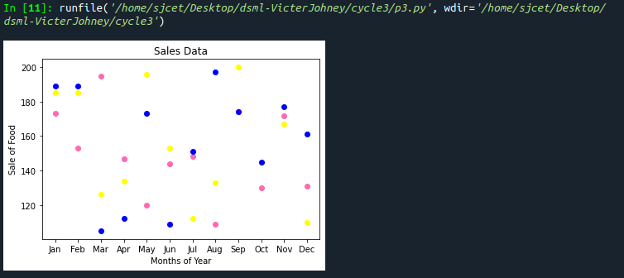
4. Display the above data using multiline plot( 3 different lines in same graph)
- Display the description of the graph in upper right corner(use legend())
- Use different colors and line styles for 3 different lines

CODE:
import matplotlib.pyplot as plt
import numpy as np
# create data
x = [1,2,3,4,5]
y = [3,3,3,3,3]
z = [4,4,4,4,4]

# plot lines
plt.plot(x, y, label = "line 1")
plt.plot(y, x, label = "line 2")
plt.plot(z, x, label = "line 3")
plt.legend()
plt.show()

OUTPUT:
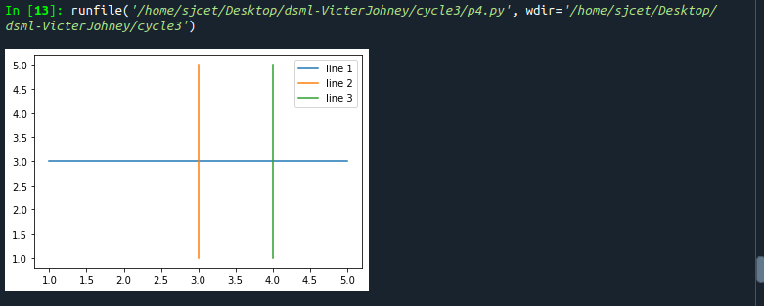
5. 100 students were asked what their primary mode of transport for getting to school was. The results of
this survey are recorded in the table below. Construct a bar graph representing this information.
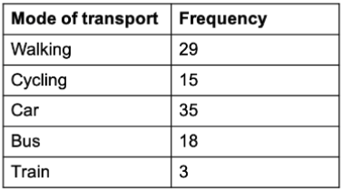

Create a bar graph with
- X axis -mode of Transport and Y axis ‘frequency’
- Provide appropriate labels and title
- Width .1, color green

CODE:
import matplotlib.pyplot as plt
import numpy as np

x = np.array(["walking", "cycling", "car", "bus","train"])
y = np.array([29,15,35,18,3])

plt.bar(x,y, color="#4CAF50",width=0.1)
plt.show()

OUTPUT:
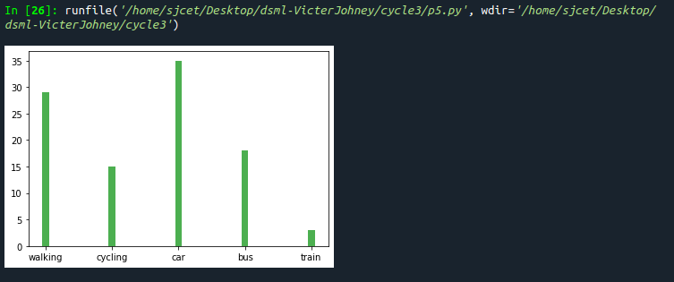
6. We are provided with the height of 30 cherry trees.
The height of the trees (in inches): 61, 63, 64, 66, 68, 69, 71, 71.5, 72, 72.5, 73, 73.5, 74, 74.5, 76, 76.2,
76.5, 77, 77.5, 78, 78.5, 79, 79.2, 80, 81, 82, 83, 84, 85, 87.Create a histogram with a bin size of 5

CODE:
import matplotlib.pyplot as plt
height = [61, 63, 64, 66, 68, 69, 71, 71.5,
72, 72.5, 73, 73.5, 74, 74.5, 76,
76.2,76.5, 77, 77.5, 78, 78.5, 79,
79.2, 80, 81, 82, 83, 84, 85, 87]
plt.hist(height, edgecolor="red", bins=5)
plt.show()

OUTPUT:
